Ms. Johnson’s Supply List 2024-2025

Grade **4**

Richmond Hill Elementary

1. Personal hand sanitizer 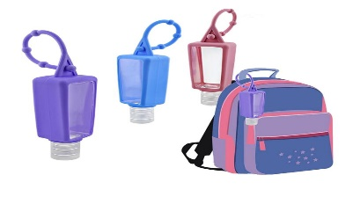
2. (1) 1 or 1 ½ inch binder
3. 6 packs of #2 pencils
4. Erasers 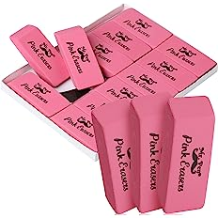 or 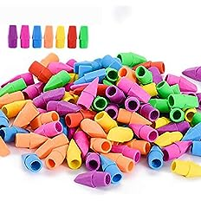
5. (6) Wide-Ruled marble composition notebooks
6. One box of highlighter
7. (1) ruler (plastic/wooden) 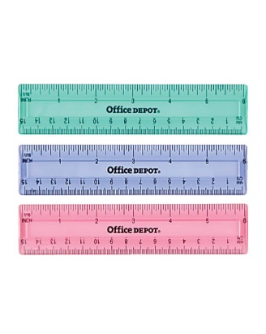 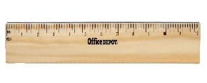
8. One zippered pencil bag (no pencil boxes) 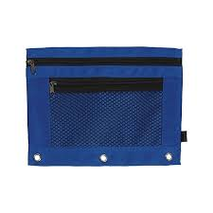
9. 2 pairs of ear phones (one pair for 1st semester and one pair for 2nd semester) 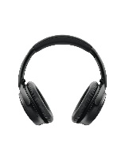

*Wish List

* (1) 2 liter bottle of hand sanitizer
* Clorox or Lysol wipes
* Tissue

*NO Pencil Sharpeners*